
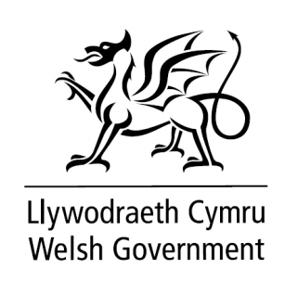


Welsh Government Placement Application Form

- Please complete this form electronically. Make sure all information fields are completed.
- You should discuss applying for a Placement with your main supervisor and work out how it would fit with your PhD project and associated training.

PLACEMENT APPLYING FOR
Please indicate the placement you are applying for.

Placement applied for (reference and title)

PLACEMENT PREFERENCE:
If your first choice of placement is unsuccessful, we will consider your second or third choice where possible.

2nd Choice (optional - reference and title)
3rd Choice (Optional - reference and title)

Title: |  | Initials: |  | Surname:

School/Department:

University:

WGSSS Pathway:

Address:
Postcode

Year of PhD |  | Tel: |  | Email:

PhD Title:

PLACEMENT START DATE

It is expected that a student will work with their supervisor to update their PhD project plan to include time off for a placement opportunity. For the benefit of successful completion, it is strongly advised that planned leave and key PhD commitments do not overlap with the period of the placement.

Please indicate your preferred start date for the placement in the box below.

Proposed Placement Start Date

SUPPORTING STATEMENT
Please write up to a maximum of 300 words setting out why you feel you would be suitable for this placement. It would be helpful if you could include:
- Relevant aspects of your background, experience and skills;
- What you feel you could bring to the role;
- What you feel the placement would mean for your career development.

SUPERVISOR DETAILS

Main supervisor
Main supervisor’s email address

Does your main supervisor give their approval and support for your application?  (please check box) | Yes | ☐
 | No | ☐

CIVIL SERVICE NATIONALITY REQUIREMENTS DECLARATION

Before submitting your application, please confirm your eligibility to apply under the Civil Service Nationality Rules.

Civil Service recruitment: nationality rules - GOV.UK

Unfortunately, we are unable to offer placements to individuals who do not meet these requirements. We ask for this confirmation now to avoid any disappointment later in the process.

Please select one of the following:

Yes, I confirm that I meet the Civil Service nationality requirements  No, I do not meet the Civil Service nationality requirements | Yes | ☐
 | No | ☐

Student Signature: |  | Date:
Print Name:

Completed application forms should be emailed to esrcrip@bangor.ac.uk
The deadline for receipt is 23:59 on 23rd November 2025

