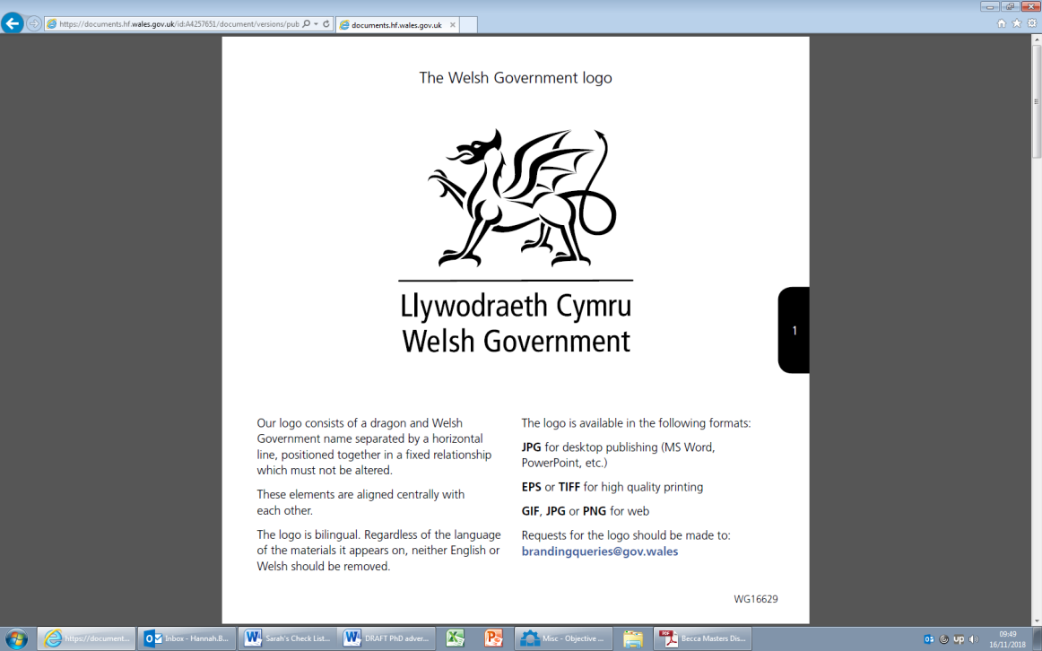
Export Programme Analysis – Survey Design & Impact Evaluation

Summary
This is an exciting opportunity to do a work placement on a project for the Welsh Government contributing to a high-impact project within the Knowledge and Analytical Services (KAS) Trade Analysis team. The successful candidate will support the Export Support Team by conducting research and analysis focused on a cohort of new exporters who have benefitted from Welsh Government support in Wales. The placement will require research with beneficiaries (potentially an online survey and follow up interviews), and analysis of findings. If there is time to undertake some smaller analytical projects while the survey is in field, this could encompass a difference-in-differences analysis as well as identifying the parameters for categorising other businesses in Wales with untapped or high-growth export potential.
The student would play a key role in helping to define the parameters and indicators that can be used to assess export readiness and growth potential. This will involve working with a range of data sources, engaging with stakeholders, and applying analytical techniques to generate insights that can inform policy and operational decisions.
This placement offers a unique opportunity to apply academic research skills in a real-world operational environment, contribute to evidence-based decision-making, and gain experience working within a multidisciplinary analytical team. The project will also support the student’s professional development by enhancing their understanding of trade policy, economic development, and the role of government in supporting business growth.

The Organisation
The Welsh Government is the devolved Government for Wales with responsibility for the economy, education, health and the Welsh NHS, business, public services and the environment of Wales.
Specifically, the internship will be based within Knowledge and Analytic services (KAS). KAS provides the collection, analysis and presentation of research and data for policymakers and the general public in keeping with professional standards. They offer independent evidence to understand, develop, implement, monitor and evaluate government policies. KAS also supports policy colleagues with policy development, implementation and delivery.

The Internship
Located within a multidisciplinary team of researchers and statisticians working on Trade analysis, Borders and Input-Output Tables, this internship will provide an exciting opportunity to work at the heart of Welsh Government. The internship will require working closely with policy officials and researchers, and will provide an opportunity to apply research skills in a policy environment, further develop generic skills (such as report writing or making presentations), and to enhance policy knowledge.
The successful candidate will benefit from development opportunities offered centrally by the Welsh Government, potentially including mentoring, shadowing, peer support and training.
Interns will benefit from the experience of working closely with the Welsh Government:
- Gaining a better understanding of the world outside of academia and increasing employability, using their knowledge and skills to contribute to the work of the Welsh Government.
- The intern’s colleagues at the Welsh Government can offer an insight into the intern’s PhD project that can contribute to the success of their thesis’, as well as networking opportunities within the policy arena linked to their research area
- Transferable skills and knowledge
- Time management skills
- Report writing skills

The Project

Export Support Intern
Background
The Export Support Team in Welsh Government would like an online survey to seek feedback on its New Exporter Programme. The aim of this survey would be to assess satisfaction and engagement with the Programme, to understand the impact that the support is providing, identify any outcomes achieved and to understand the background of the businesses responding. The survey results will inform decisions around any possible extension of the Programme.
If the internship allows for further work, there would be a potential requirement to undertake further analysis on an extant survey dataset of beneficiaries and non-beneficiaries of other welsh government export support. This would encompass a difference-in-differences counterfactual analysis; as well as identifying the parameters for categorising businesses in Wales who may have untapped or high-growth export potential.
Anticipated project outcomes:
- Analytical Report: A comprehensive report summarising findings from both secondary research (e.g. literature reviews, policy context) and primary analysis (e.g. survey responses, interviews). This will include insights into business engagement, satisfaction with the New Exporter Programme, and any reported outcomes or impacts.
- Survey Results Summary: A focused results report, similar in format to the Export Cluster Programme: feedback survey results, presenting key metrics, respondent profiles, and thematic analysis of feedback. This will support decision-making around the potential extension or refinement of the Programme.
- Presentation of Findings: A concise and accessible presentation of the research findings, suitable for internal stakeholders and policy teams. This will highlight key evidence, implications for future support, and recommendations for identifying businesses with untapped or high-growth export potential.

Internship responsibilities and requirements
The internship will last for a maximum of 3 months. Full time students are expected to step back from their PhD to focus on the placement for its duration in line with ESRC guidelines (ESRC Postgraduate Funding Guide p. 27). Applications are encouraged from part-time students.
It is anticipated that the successful applicant will work in a hybrid way between home and a Welsh Government office during their internship. This may change depending on Welsh Government policy. Any changes to working arrangements will be discussed with successful applicants.
The internship will last for a period of 3 months full-time or the part-time equivalent. For students registered on a part-time studentship, this internship is available on a part-time basis over a longer time frame (no fewer than three days a working week), this would be negotiated between the WG and the successful applicant. If you would like to be considered on a part-time basis, please specify your preferred working hours on the application form.
Student specification

The student must have:
- Strong analytical skills, with the ability to critically assess and interpret both quantitative and qualitative data.
- Experience in analysing survey data and presenting findings using clear, well-structured charts and visualisations.
- Proven ability to produce concise, well-written documents that communicate technical material in an accessible format.
- Ability to work independently and manage competing priorities to meet tight deadlines.
- Excellent interpersonal and communication skills, including the ability to engage with stakeholders and present findings effectively.
It would be desirable for the student to have:
- An understanding of the business landscape in Wales, particularly in relation to export activity and government support programmes.

Start date of internship
Mid-January 2026 (exact date can be discussed/agreed), There may be some flexibility dependent on individual circumstances.

Funding and costs
Reasonable travel costs for students not normally based in Cardiff can be met. Requests should be consistent with Wales Graduate School for the Social Sciences (WGSSS) guidelines. Applications from students requiring additional funding for travel and accommodation will not be treated less favourably. For any queries on this please contact Katy Marrin Katy.Marrin001@gov.wales and Jo Coates Joanne.Coates@gov.wales.

Security
The Welsh Government’s vetting procedures (which apply to temporary as well as permanent staff) involve the completion of a Baseline Personnel Security Standard (BPSS) application form and a Security Questionnaire for the purpose of security vetting.
This process requires the applicant to produce in person three original forms of identification documents, one of which should be photographic (passport, new driving license), one document should showing their current address, plus one of: a utility bill, birth certificate, P45 or P60.

Nationality requirements
'Eligibility for taking up an internship on this scheme is dependent on meeting the Civil Service Nationality rules. Please check that you are eligible before applying. Those who do not meet the eligibility criteria will not be able to take up a placement opportunity.
Queries
Any queries relating to the post or application process should be directed to: Cerys Ponting, Head of Trade Analysis - Cerys.Ponting@gov.wales
Privacy Notice https://www.gov.wales/welsh-government-privacy-notice

